

DLD Couse Assignment#3

By:  
  
Name:  
Abdul-Rehman  
Roll.no:  
19l-1135  
Section:   
CS-D

**Q-1**

**Circuit:**

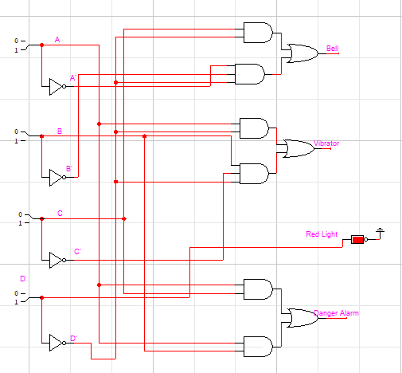

Truth Table:

|  |  |  |  |  |  |  |  |
| --- | --- | --- | --- | --- | --- | --- | --- |
| A | B | C | D | BELL | VIB | RL | DA |
| 0 | 0 | 0 | 0 | 1 | 0 | 0 | 0 |
| 0 | 0 | 0 | 1 | 0 | 0 | 1 | 0 |
| 0 | 0 | 1 | 0 | 1 | 0 | 0 | 0 |
| 0 | 0 | 1 | 1 | 0 | 0 | 1 | 0 |
| 0 | 1 | 0 | 0 | 0 | 1 | 0 | 0 |
| 0 | 1 | 0 | 1 | 0 | 0 | 1 | 0 |
| 0 | 1 | 1 | 0 | 1 | 0 | 0 | 0 |
| 0 | 1 | 1 | 1 | 0 | 0 | 1 | 0 |
| 1 | 0 | 0 | 0 | 0 | 1 | 0 | 0 |
| 1 | 0 | 0 | 1 | 0 | 0 | 1 | 0 |
| 1 | 0 | 1 | 0 | x | x | x | 1 |
| 1 | 0 | 1 | 1 | x | x | x | 1 |
| 1 | 1 | 0 | 0 | x | x | x | 1 |
| 1 | 1 | 0 | 1 | x | x | x | 1 |
| 1 | 1 | 1 | 0 | x | x | x | 1 |
| 1 | 1 | 1 | 1 | x | x | x | 1 |
| Equations: |  |  |  |  |  |  |  |
| Bell= CD' + A'B'D' | | |  |  |  |  |  |
| VIB = AD' + BC'D' | | |  |  |  |  |  |
| RL = D |  |  |  |  |  |  |  |
| DA = AC + AB | |  |  |  |  |  |  |

**Q-2**

6X64 Decoder:

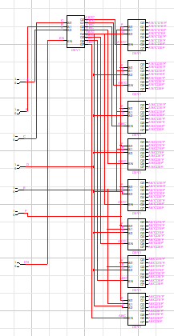

**Q-3**

(a)

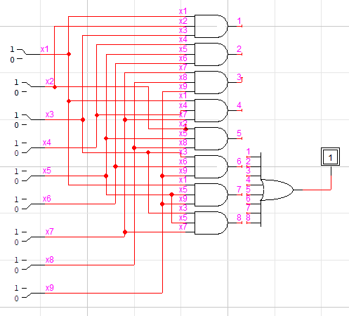

(b)

W= X1.X2.X3+X4.X5.X6+X7.X8.X9+X1.X4.X7+X2.X5.X8+X3.X6.X9+X1.X5.X9+X3.X5.X7  
  
The above equation for the W output cannot be further simplified using Boolean algebra.

**Q-4**

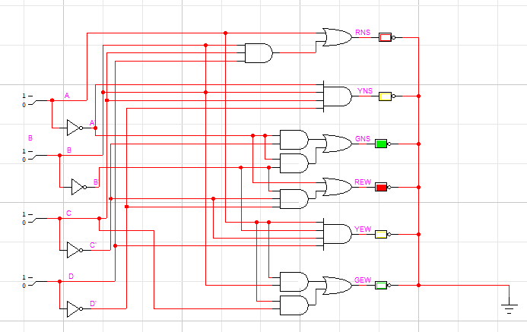

TRUTH TABLE:

|  |  |  |  |  |  |  |  |  |  |
| --- | --- | --- | --- | --- | --- | --- | --- | --- | --- |
| A | B | C | D | RNS | YNS | GNS | REW | YEW | GEW |
| 0 | 0 | 0 | 0 | 0 | 0 | 1 | 1 | 0 | 0 |
| 0 | 0 | 0 | 1 | 0 | 0 | 1 | 1 | 0 | 0 |
| 0 | 0 | 1 | 1 | 0 | 0 | 1 | 1 | 0 | 0 |
| 0 | 0 | 1 | 0 | 0 | 0 | 1 | 1 | 0 | 0 |
| 0 | 1 | 1 | 0 | 0 | 0 | 1 | 1 | 0 | 0 |
| 0 | 1 | 1 | 1 | 0 | 0 | 1 | 1 | 0 | 0 |
| 0 | 1 | 0 | 1 | 0 | 1 | 0 | 1 | 0 | 0 |
| 0 | 1 | 0 | 0 | 1 | 0 | 0 | 1 | 0 | 0 |
| 1 | 1 | 0 | 0 | 1 | 0 | 0 | 1 | 0 | 0 |
| 1 | 1 | 0 | 1 | 1 | 0 | 0 | 0 | 1 | 0 |
| 1 | 1 | 1 | 1 | 1 | 0 | 0 | 0 | 0 | 1 |
| 1 | 1 | 1 | 0 | 1 | 0 | 0 | 0 | 0 | 1 |
| 1 | 0 | 1 | 0 | 1 | 0 | 0 | 0 | 0 | 1 |
| 1 | 0 | 1 | 1 | 1 | 0 | 0 | 0 | 0 | 1 |
| 1 | 0 | 0 | 1 | 1 | 0 | 0 | 0 | 0 | 1 |
| 1 | 0 | 0 | 0 | 1 | 0 | 0 | 0 | 0 | 1 |

**Q-5**

Truth Table:

|  |  |  |  |  |  |  |
| --- | --- | --- | --- | --- | --- | --- |
| PS | LS | RS | RR | PL | LL | RL |
| 0 | 0 | 0 | 0 | 0 | 0 | 0 |
| 0 | 0 | 0 | 1 | 0 | 0 | 0 |
| 0 | 0 | 1 | 0 | 0 | 0 | 1 |
| 0 | 0 | 1 | 1 | 0 | 0 | 1 |
| 0 | 1 | 0 | 0 | 0 | 1 | 0 |
| 0 | 1 | 0 | 1 | 0 | 1 | 0 |
| 0 | 1 | 1 | 0 | 0 | 0 | 1 |
| 0 | 1 | 1 | 1 | 0 | 1 | 0 |
| 1 | 0 | 0 | 0 | 1 | 0 | 0 |
| 1 | 0 | 0 | 1 | 1 | 0 | 0 |
| 1 | 0 | 1 | 0 | 1 | 0 | 0 |
| 1 | 0 | 1 | 1 | 1 | 0 | 0 |
| 1 | 1 | 0 | 0 | 1 | 0 | 0 |
| 1 | 1 | 0 | 1 | 1 | 0 | 0 |
| 1 | 1 | 1 | 0 | 1 | 0 | 0 |
| 1 | 1 | 1 | 1 | 1 | 0 | 0 |

Equations:

|  |  |  |
| --- | --- | --- |
| PL=PS |  |  |
| LL=PS'LSRS'+PS'LSRR | |  |
| RL=PS'LS'RS+PS'RSRR' | | |

Circuit:

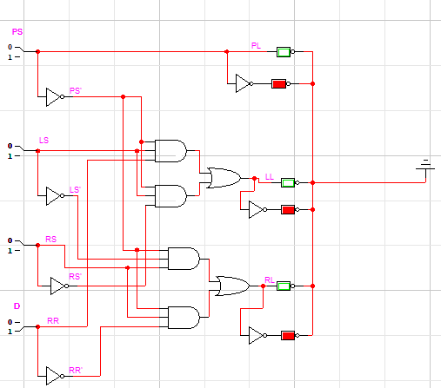

**Q-6**

**Original Circuit: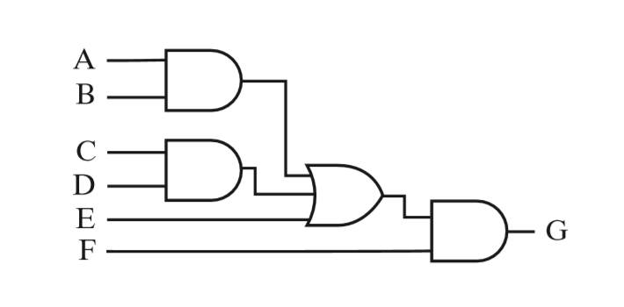Circuit after technological mapping by NOR gates:**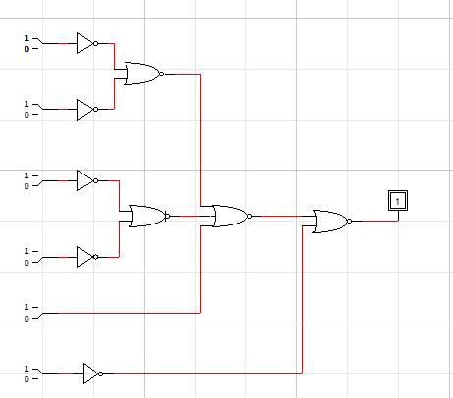

**Q-7**

**Design:**

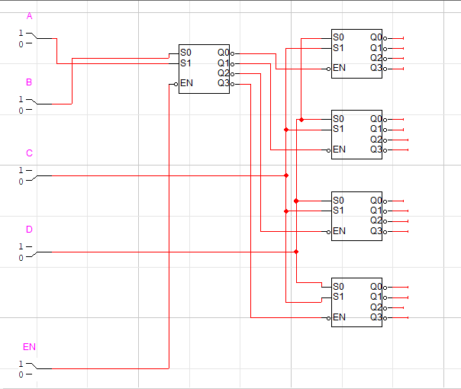

**Q-8**

**Original Truth Table:**

**With Priority Bit as D3.**

|  |  |  |  |  |  |  |
| --- | --- | --- | --- | --- | --- | --- |
| INPUTS | | |  | OUTPUT | |  |
| D3 | D2 | D1 | D0 | A1 | A0 | V |
| 0 | 0 | 0 | 0 | x | x | 0 |
| 0 | 0 | 0 | 1 | 0 | 0 | 1 |
| 0 | 0 | 1 | x | 0 | 1 | 1 |
| 0 | 1 | x | x | 1 | 0 | 1 |
| 1 | x | x | x | 1 | 1 | 1 |

**New Truth Table:**

**With Priority Bit as D0.**

|  |  |  |  |  |  |  |
| --- | --- | --- | --- | --- | --- | --- |
| INPUTS | | |  | OUTPUT | |  |
| D3 | D2 | D1 | D0 | A1 | A0 | V |
| 0 | 0 | 0 | 0 | x | x | 0 |
| 0 | 0 | 0 | 1 | 1 | 1 | 1 |
| 0 | 0 | 1 | x | 1 | 0 | 1 |
| 0 | 1 | x | x | 0 | 1 | 1 |
| 1 | x | x | x | 0 | 0 | 1 |
| THANK YOU |  |  |  |  |  |  |
|  |  |  |  |  |  |  |

